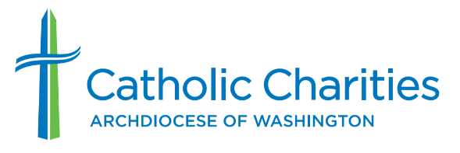

Media Contact
Foster Dennin
Foster.Dennin@cc-dc.org
202-772-4346

Catholic Charities’ Southern Maryland Food Bank to Honor Its Community Partners at 40th Anniversary Dinner
15+ million pounds of food have been given out since food bank’s opening in 1983

WALDORF, Md., Aug. 21, 2023 — Catholic Charities’ Southern Maryland Food Bank and Outreach Services will honor 35 local food pantries and other supporters at a special 40th anniversary dinner on Sept. 15.

Founded in 1983, the Southern Maryland Food Bank has grown from a storage unit in Indian Head, Md., to a multi-service program in a 4,300-square-foot facility in Waldorf. With the help of dedicated volunteers and community supporters, Catholic Charities’ Southern Maryland Foodbank has been an instrumental force in combating food insecurity and hunger in Charles and St. Mary’s counties.

The anniversary dinner will highlight the food bank’s achievements with brief remarks from community leaders and a recipient of the food bank’s services. George Mattingly, food bank and outreach services manager, will present commendations to pantry partners and recognize special donors. Brenda DiCarlo, the food bank’s previous manager, will receive special recognition for her past work growing the food bank.

What: Southern Maryland Food Bank and Outreach Services’ 40th Anniversary Celebration (by invitation only)

When: 5-7 p.m. Friday, Sept. 15, 2023

Where: Waldorf Jaycees Community Center, 3090 Crain Highway, Waldorf, MD 20601
Program: A short program will feature remarks by Jim Malloy, president and CEO of Catholic Charities of the Archdiocese of Washington; Ralph E. Patterson II, vice president, Charles County Commissioners; and Andrill Harris, community school coordinator at Dr. Samuel A. Mudd Elementary School, a recipient of the food bank’s Snack Saks program. Jimmy Guy will serve as master of ceremonies.
Details: As a distribution partner of the Maryland Food Bank, the Southern Maryland Food Bank provides food to community-based pantries in Charles and St. Mary’s counties. It operates its own food pantry in Charles County, the Seeds of Hope community garden and the Meals & Hope mobile food truck, which has given out more than 32,000 hot meals in its seven years of operation. Since 2010, the food bank has provided more than 176,000 nourishing food packages to vulnerable children and seniors in Charles and St. Mary’s counties through Snack Saks and Senior Saks programs.

Media: The anniversary celebration is open to media coverage. An RSVP is required to attend. To RSVP, contact Foster Dennin of Catholic Charities’ communications department at Foster.Dennin@cc-dc.org or 202-772-4346.

Photos and video will be posted on social media @CCADW after the event.

About Catholic Charities of the Archdiocese of Washington
Catholic Charities DC is the largest independent social services agency in the Metropolitan D.C. area. As the charitable arm of the Archdiocese of Washington, Catholic Charities DC invests in communities by providing critical services to hundreds of thousands of people in need throughout the District of Columbia and Montgomery, Prince George’s, Charles, Calvert and St. Mary’s counties in Maryland. The organization works tirelessly to give help that empowers and hope that lasts to those it serves regardless of background, belief, or circumstance. For more information, visit www.catholiccharitiesdc.org and follow us on social media @CCADW.

